

**AMERICAN INTERNATIONAL UNIVERSITY–BANGLADESH (AIUB)**

**DEPARTMENT OF COMPUTER SCIENCE AND TECHNOLOGY**

**Summer 2021-2022**

**Section: L**

Introduction to database project:

# School Management System

**Supervised By**

**MD SAJID BIN -FAISAL**

**Submitted By**

# Group 7

|  |  |  |
| --- | --- | --- |
| **Serial** | **Student Name** | **Student ID** |
| **1.** | **SALMAN AREFIN** | **22-47262-1** |
| **2.** | **MAHAMODUL HASAN TAJ** | **22-47271-1** |
| **3.** | **MUHAMMAD IMTIAZ SHAHARIA** | **22-47064-1** |
| **4** | **Ahamed Mashruf** | **22-46073-1** |

School Management System

# Introduction

We are trying to make a primary school management system, so we decided to build a school management system with oracle SQL developer. We tried to solve the school data management problems automatically by the software.

Scenario

In the school management system, we will include students of every class, every class has one class teacher assigned but there are many teachers in school who will also in employee and teachers’ group. That teacher must be in under a department. Department has employees, teachers and other staff. Students will be in a specific branch of the school. In the department table, we will include all the necessary employees who are involved in schoolwork. Every employee has detailed information about the salary, commission, communication detail etc. There will be teacher information and teacher details like salary, department etc. Mainly we highlight employees and their job, class, teacher, library. All the people in a school are in person entity. To be a student, teacher, member you must be a person of the school with any department. If any ore are not in person of a school, then he or she will not be a part of school. This management system can manage more than one branch of the school and thousands of students, teacher, employees and this can keep all the information for future use.

Normalization

**ENROLLS**

UNF: S-ID, S-Phone, S-Dob, S-name, School-id, Email, Class, Zip, City, Country, Numbers, Building number, class, Class-ID, Room number, Section

1NF: S-id, S-phone, S-dob, S-name, School-id, Email, Class, Zip, City, Country, S.id, Building number, Class,Class-ID, Room number, Section

2NF: i) S-id, S-phone, S-dob, S-name, School-id, Email, Zip, City, Country

ii) Room number, Building number, Class-id, section, Class, S-ID(fk)

3NF: i) S-id, S-phone, S-dob, S-name, School-id, Email.

ii) City, Zip, Country

iii) Room number, Building number, Class-ID, Section, S-ID(fk)

TAKES:

UNF: T. Phone, T.ID, T. Name, Class.ID, Class, Building number, Emp.No, C. Id, Subject, Address, Zip, City, Country, Email, Room.no, S.id, Section

1NF: T.ID, T. Name,T.Phone, Room.no, S.id, Section, Class.ID, Class, Building number, Emp.No, C. Id, Subject, Email, Zip, City, Country

2NF: i) Room.no, S.id, Section, Class.ID, Class, Building number

ii) T. Phone, T.ID, T. Name, Emp.No,Subject, Address, Email, Zip, City, Country, Class.ID(fk)

1. T.ID, Class_ID(fk)

3NF:

1. Class.ID, Class, Room.no, S.id, Section, Building number
2. Zip, City, Country Zip, City, Country
3. T. Phone, T.ID, T. Name,Emp.No, Class. Id(fk), Subject, Address, Email
4. T.ID, Class.Id(fk)

HAS:

UNF: S. Phone, S. Name, School ID, S. Date,Email, Address, City, Zip, Country, S.B. Number, Billing Number, E. Job, Emp.No, Comm, Dept No, E. Name, Room No, Salary, School Id, Joining Date

1NF: S. Phone, S. Name, School ID, S. Date, Email,City, Zip, Country, S.B. Number, Billing Number, E. Job, Emp.No, Comm, Dept No, E. Name, Room No, Salary, School Id, Joining Date

2NF:

1. S. Phone, S. Name, School ID, S. Date,Email, City, Zip, Country, S.B. Number
2. E.Name, E. Job, Emp.No, Comm, Dept No, Billing Number, Room No, Salary, School ID (fk), Joining Date

3NF:

1. S. Phone, S. Name, School ID, S. Date,Email, City, Zip, Country, S.B. Number
2. Zip, City, Country
3. E.Name,E. Job, Emp.No, Comm, Dept No, Billing Number, Room No, Salary, School ID (fk), Joining Date

IS A

UNF: Emp. No, C. Id, Subject, Address, Zip, City, Country, Email, T. Phone, T.ID, T. Name, Billing Number, E. Job, Emp.No, Comm, Dept No, E. Name, Room No, Salary, School Id, Joining Date

1NF: Emp. No, C. Id, Subject, Zip, City, Country, Email, T. Phone, T.ID, T. Name, Billing Number, E. Job, Comm, Dept No, E. Name, Room No, Emp.No, Salary, School Id, Joining Date

2NF:

1. T. Phone, T.ID, T. Name ,Emp. No, C. Id, Subject, Zip, City, Country, Email
2. Billing Number, E. Job, Emp.No, Comm, Dept No, E. Name, Room No, Salary, School Id, Joining Date,T.ID(fk)
3. Emp.No, T.ID(fk)

3NF:

1. Emp. No, C. Id, Subject, Zip, City, Country, Email, T. Phone, T.ID, T. Name
2. Zip, City, Country
3. Billing Number, E. Job, Emp.No, Comm, Dept No, E. Name, Room No, Salary, School Id, Joining Date,T.ID(fk)
4. Emp. No, T.ID(fk)

HAS:

UNF: L.ID, Job, School ID, L.ID, Book. ID, B. Self, B. Date, Book Name, Block

1NF: L.ID, Job, School ID, L.ID, Book. ID, B. Self, B. Date, Book Name, Block

2NF:

1. L.ID, Job, School ID
2. Book. ID, B. Self, B. Date, Book Name, Block, L.ID (fk)

3NF: SAME AS 2NF

HAS:

UNF: L.ID, School id, job, M.ID, M.Name, M.Date, L.Id

1NF: L.ID, school id, job, M.ID, M.Name, M.Date, L.Id

2NF:

1. L.ID, school id, job
2. M.ID, M.Name, M.Date, L.ID(fk)

3NF:

1. L.ID, school id, job
2. M.ID, M.Name, M.Date, L.ID(fk)
3. M.ID L.ID(fk)

Belongs To:

UNF: P.no, P.name, P.job, S.phone, Email, Class, s.Id, s.name, Address, zip, city, country, s.dob, school id

1NF: P.no, P.name, P.job, S. phone, Email, Class, s.Id, s.name, zip, city, country, s.dob, school id

2NF:

1. P.No, P.Name, P.job
2. S. phone, Email, Class, S. Id, s.name, zip, city, country, s.dob, school id, P.No (fk)

3NF:

1. P.no, P.name, P.job
2. zip, city, country
3. S. phone, Email, Class, S.Id, s.name, s.dob, school id, P.No (fk)
4. S. Id ,P. no(fk)

Has:

UNF: P.no, P.name, P.job, L. Id, Job, School id

1NF: P.no, P.name, P.job, L. Id, Job, School id

2NF:

1. P.No, P.Name, P.job
2. L.Id, job, school id, P.No (fk)

3NF: SAME AS 2NF

Belongs To:

UNF: P.No, P.Name, P.job, L.id, M.id, M.name, M. date

1NF: P.No, P.Name, P.job, L.id, M.id, M.name, M. date

2NF:

1. P.no, P.name, P.job
2. L.id, M.id, M.name, M. date,P.No(fk)

3NF: SAME AS 2NF

Belongs To:

UNF: S. phone, Email, Class, S.id, S.name, Address, Zip, City, Country, S.dob, School id, T.name, T.id, T. phone, Email, Address, Zip, City, Country, Subject, c.id, empno

1NF: S. phone, Email, Class, S.id, S.name, Zip, City, Country, S.dob, School id, T.name, T.id, T. phone, Subject, c.id, empno

2NF:

1. S. phone, email, class, S.id, s.name, zip, city, country, s.dob, school id
2. T.Name, T.Id, T. phone, Subject, C.id, Empno, S.id (fk)

3NF:

1. s. phone, email, class, s.id, s.name, s.dob, school id
2. zip, city, country
3. T.Name, T.Id, T. phone, Subject, C.id, Empno, S.id (fk)

IN:

UNF: S. phone, s.name, School id, S. date,Email Address, zip, city, country, S.B. Number, Room No, S.Id , Section, Class id, Class, Building number

1NF: S. phone, s.name, School id, S. date,Email, zip, city, country, S.B. Number, Room No, S.Id , Section, Class id, Class, Building number

2NF:

1. S. phone, S.name, School id, S. date,Email zip, city, country, S.B. Number
2. Room No, Section, Class id, Class, Building number,School.Td(fk)

3NF:

1. Email, S. phone, s.name, school id, S. date, S.B. Number
2. zip, city, country
3. Room No, S. Id(fk), Section, Class id, Class, Building number

Finalization

i) S-id, S-phone, S-dob, S-name, School-id, Email.

ii) City, Zip, Country

iii) Room number, Building number, Class-ID, Section, S-ID(fk)

Iv) Class.ID, Class, Room.no, S.id, Section, Building number

V) T. Phone, T.ID, T. Name,Emp.No, Class. Id(fk), Subject, Address, Email

vi) T.ID, Class.Id(fk)

1. S. Phone, S. Name, School ID, S. Date,Email, City, Zip, Country, S.B. Number
2. E.Name,E. Job, Emp.No, Comm, Dept No, Billing Number, Room No, Salary, School ID (fk), Joining Date
3. Emp. No, C. Id, Subject, Zip, City, Country, Email, T. Phone, T.ID, T. Name
4. Billing Number, E. Job, Emp.No, Comm, Dept No, E. Name, Room No, Salary, School Id, Joining Date,T.ID(fk)
5. Emp. No, T.ID(fk)
6. L.ID, Job, School ID
7. Book. ID, B. Self, B. Date, Book Name, Block, L.ID (fk)
8. M.ID, M.Name, M.Date, L.ID(fk)
9. M.ID L.ID(fk)
10. S. phone, Email, Class, S.Id, s.name, s.dob, school id, P.No (fk)
11. S. Id ,P. no(fk)
12. P.No, P.Name, P.job
13. L.Id, job, school id, P.No (fk)
14. S. phone, email, class, s.id, s.name, s.dob, school id
15. Room No, S. Id(fk), Section, Class id, Class, Building number

ER Diagram

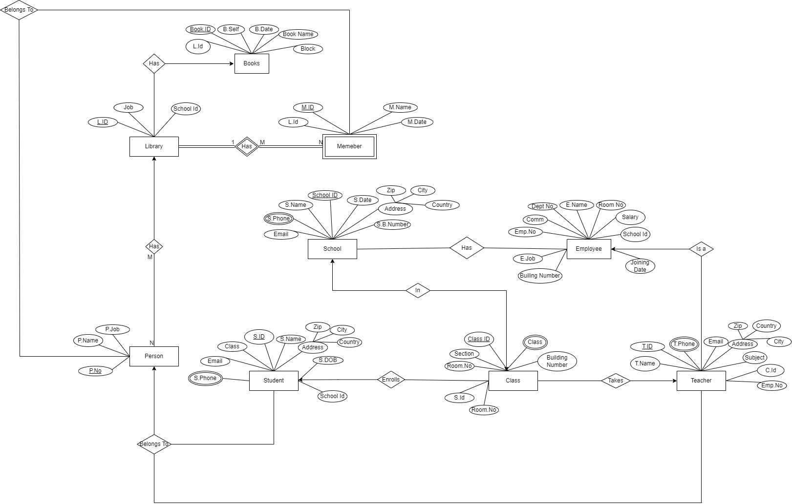

Table Creation

SCHOOL1 TABLE

SCHCLASS3 TABLE

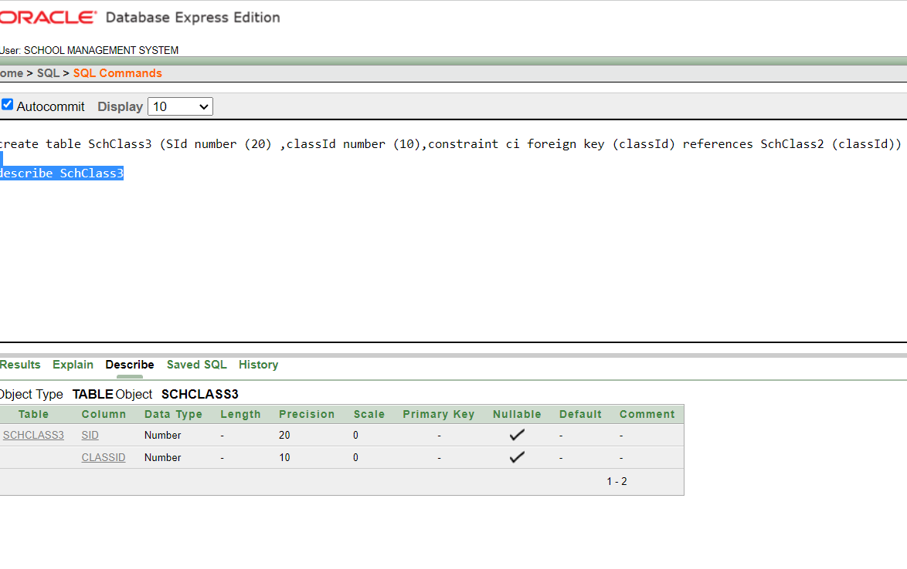

SCHCLASS2 TABLE

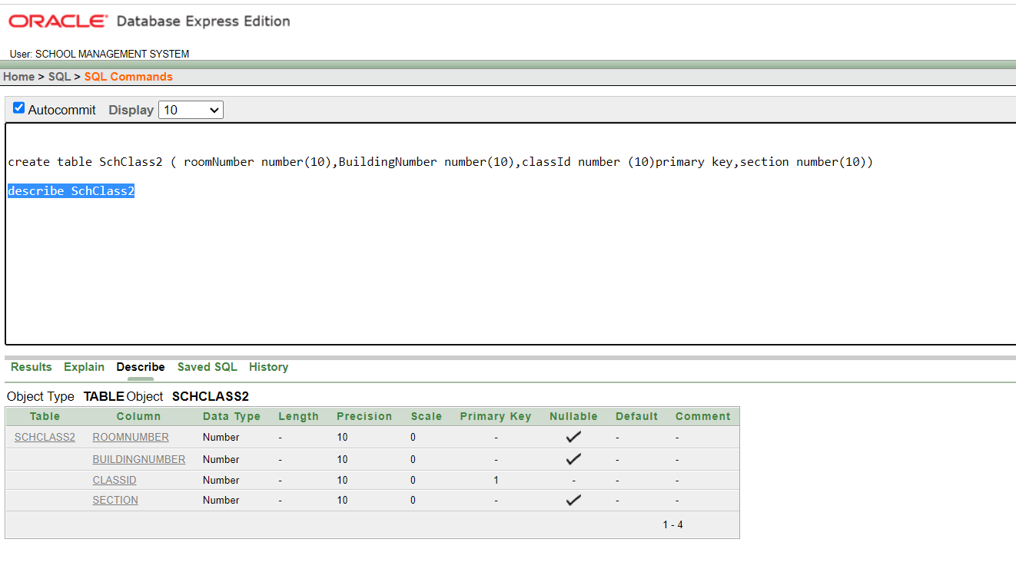

SCHCLASS1 TABLE

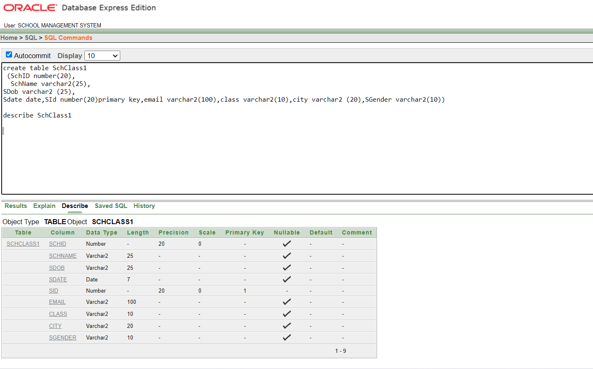

PM3 TABLE

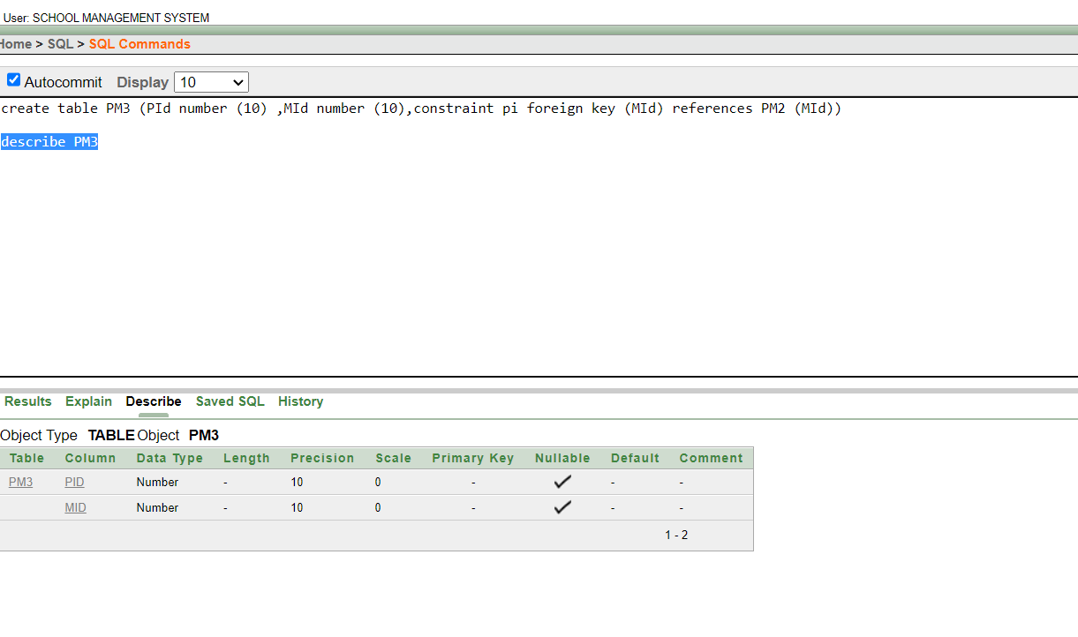

PM2 TABLE

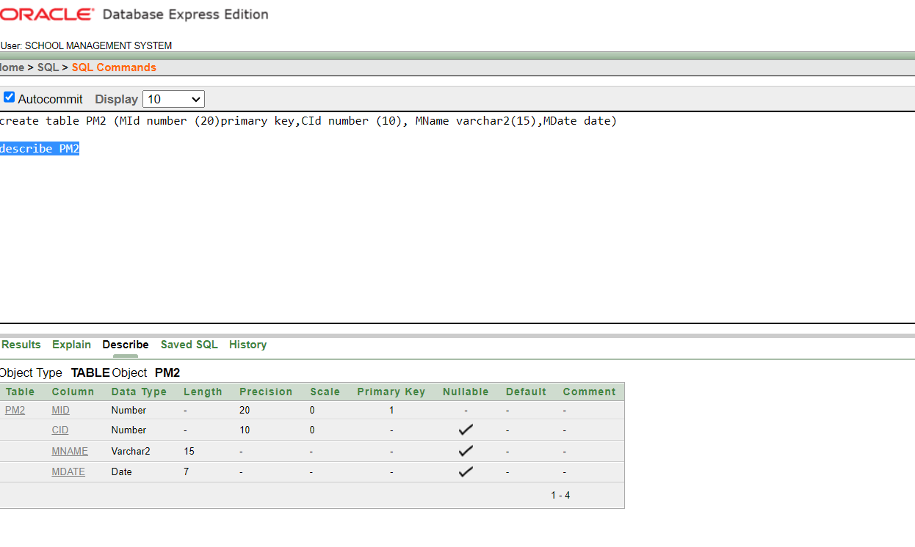

PM1 TABLE

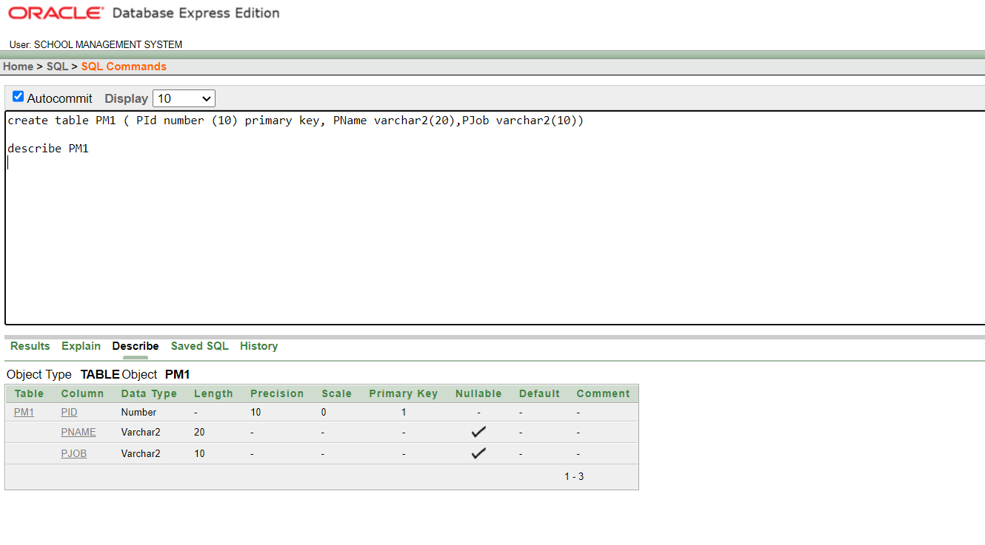

MM TABLE

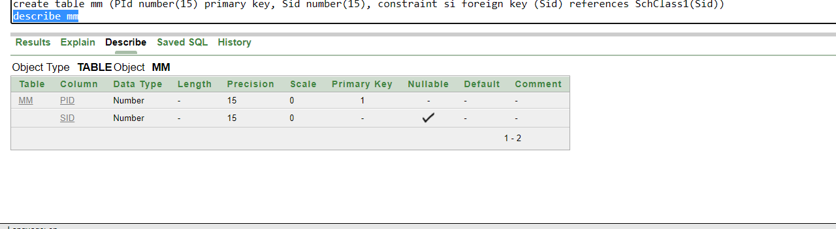

MEMBER1 TABLE

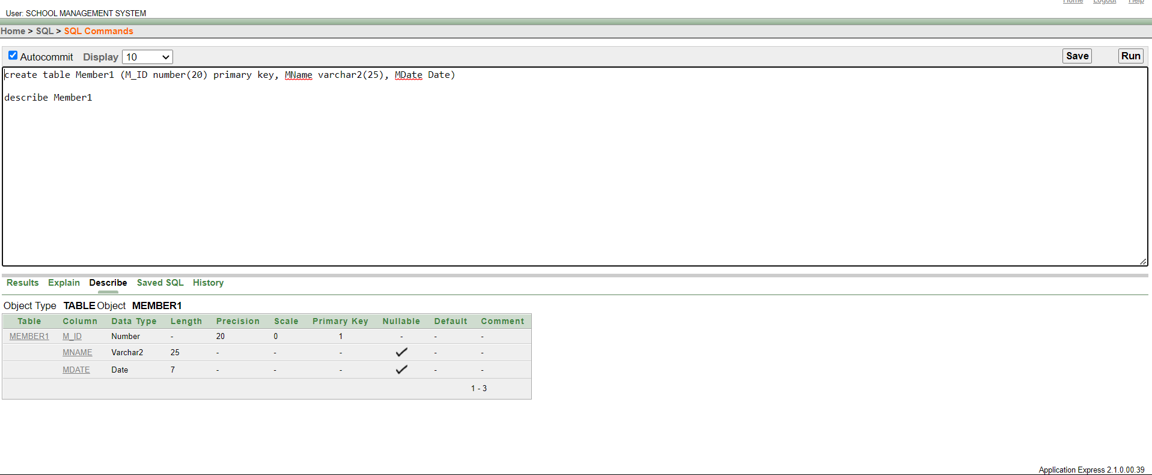

LIBRARY1 TABLE

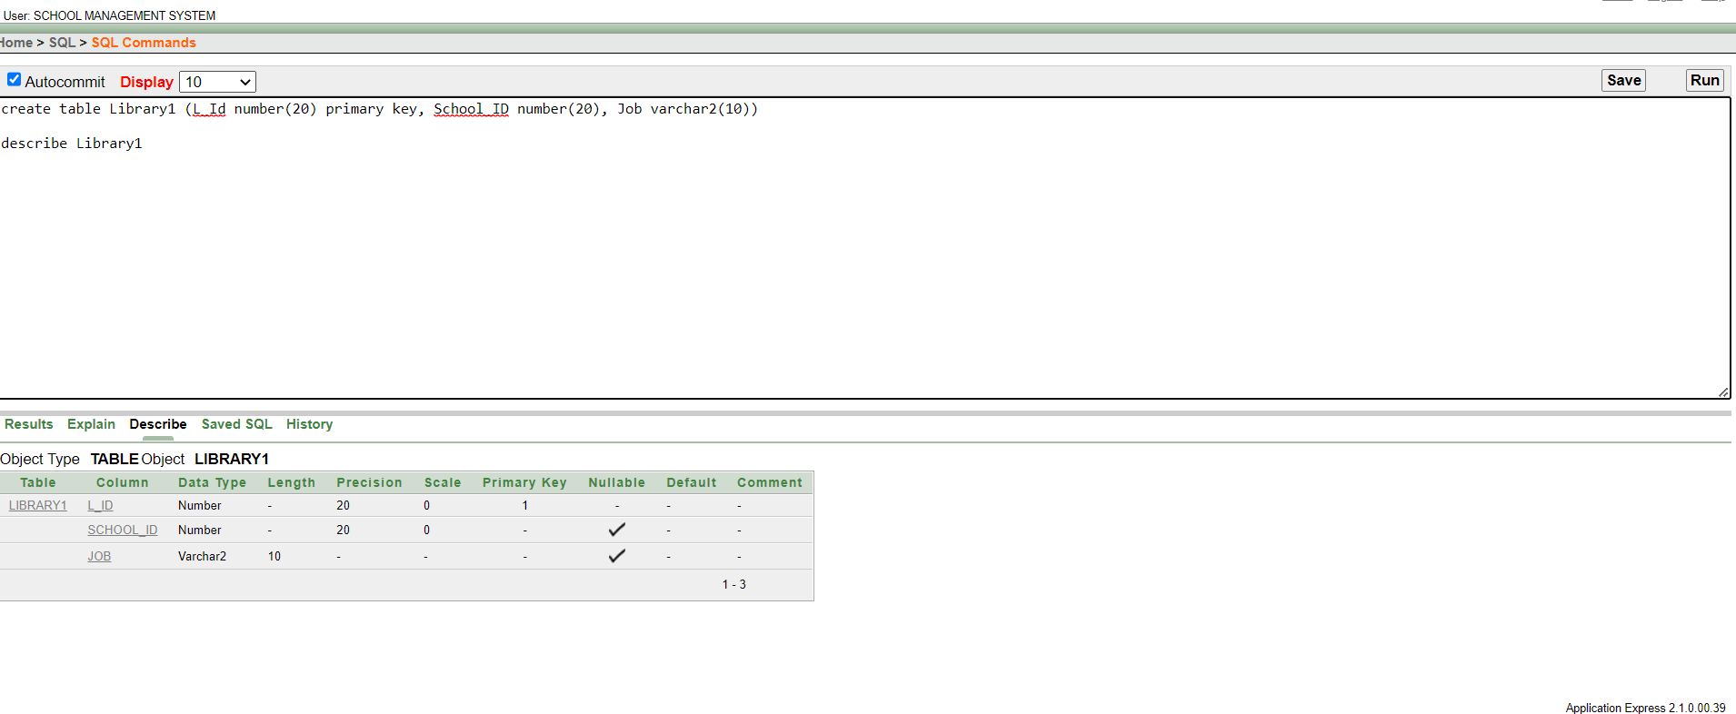

HAS2 TABLE

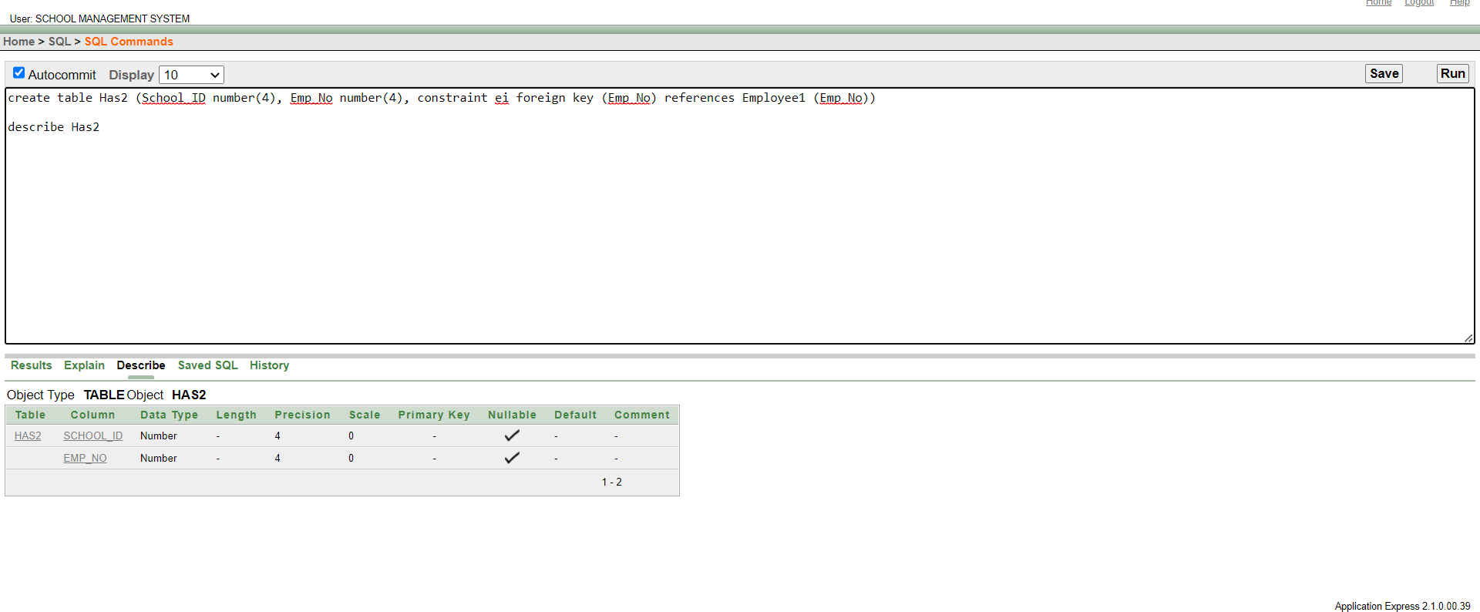

HAS1 TABLE

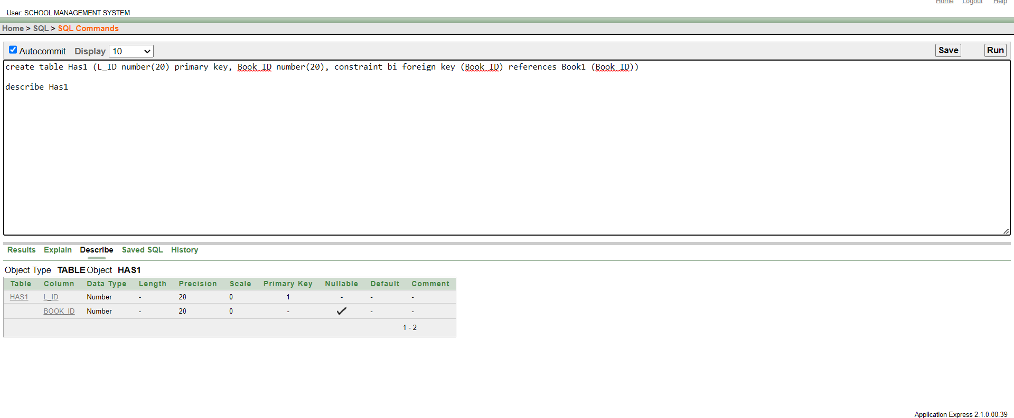

HAS TABLE

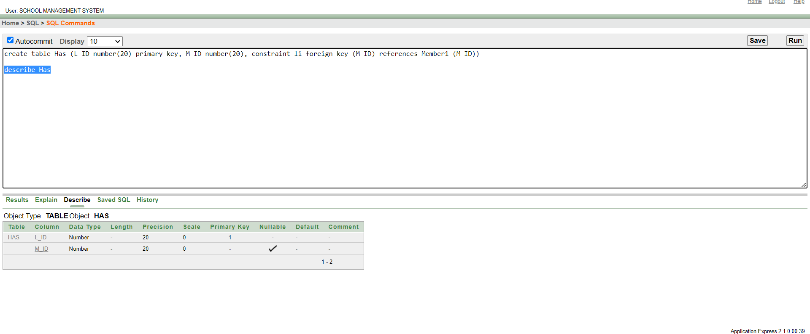

MM TABLE

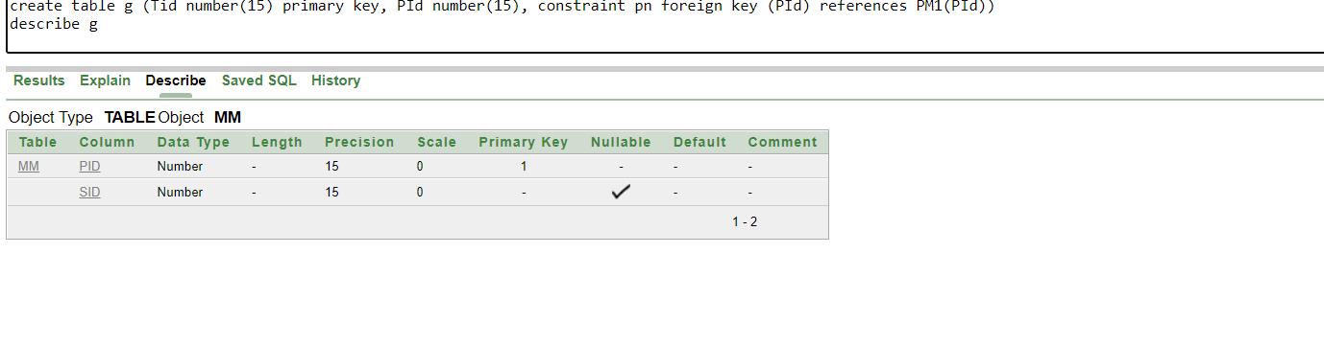

F TABLE

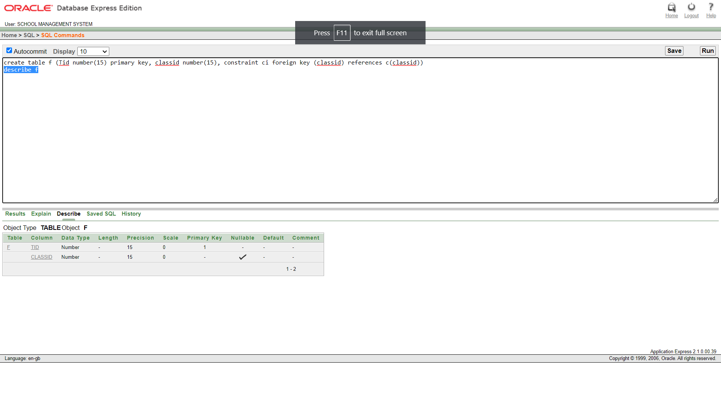

EMPLOYEE1 TABLE

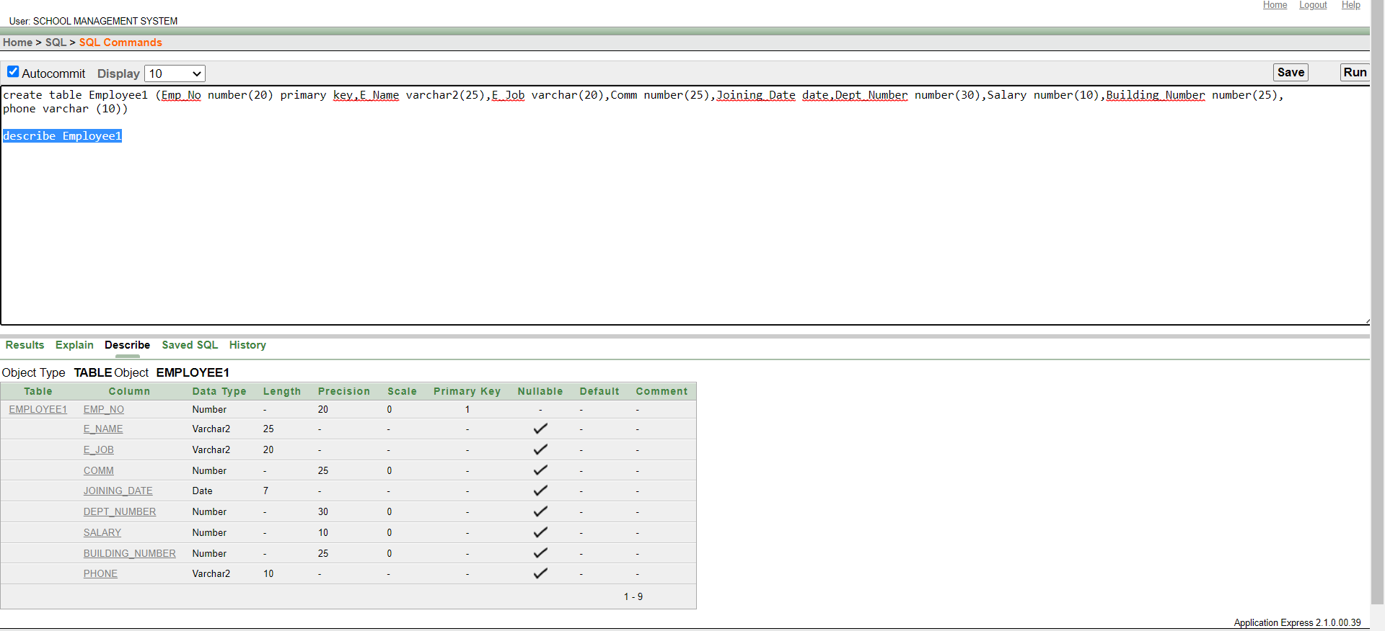

C TABLE

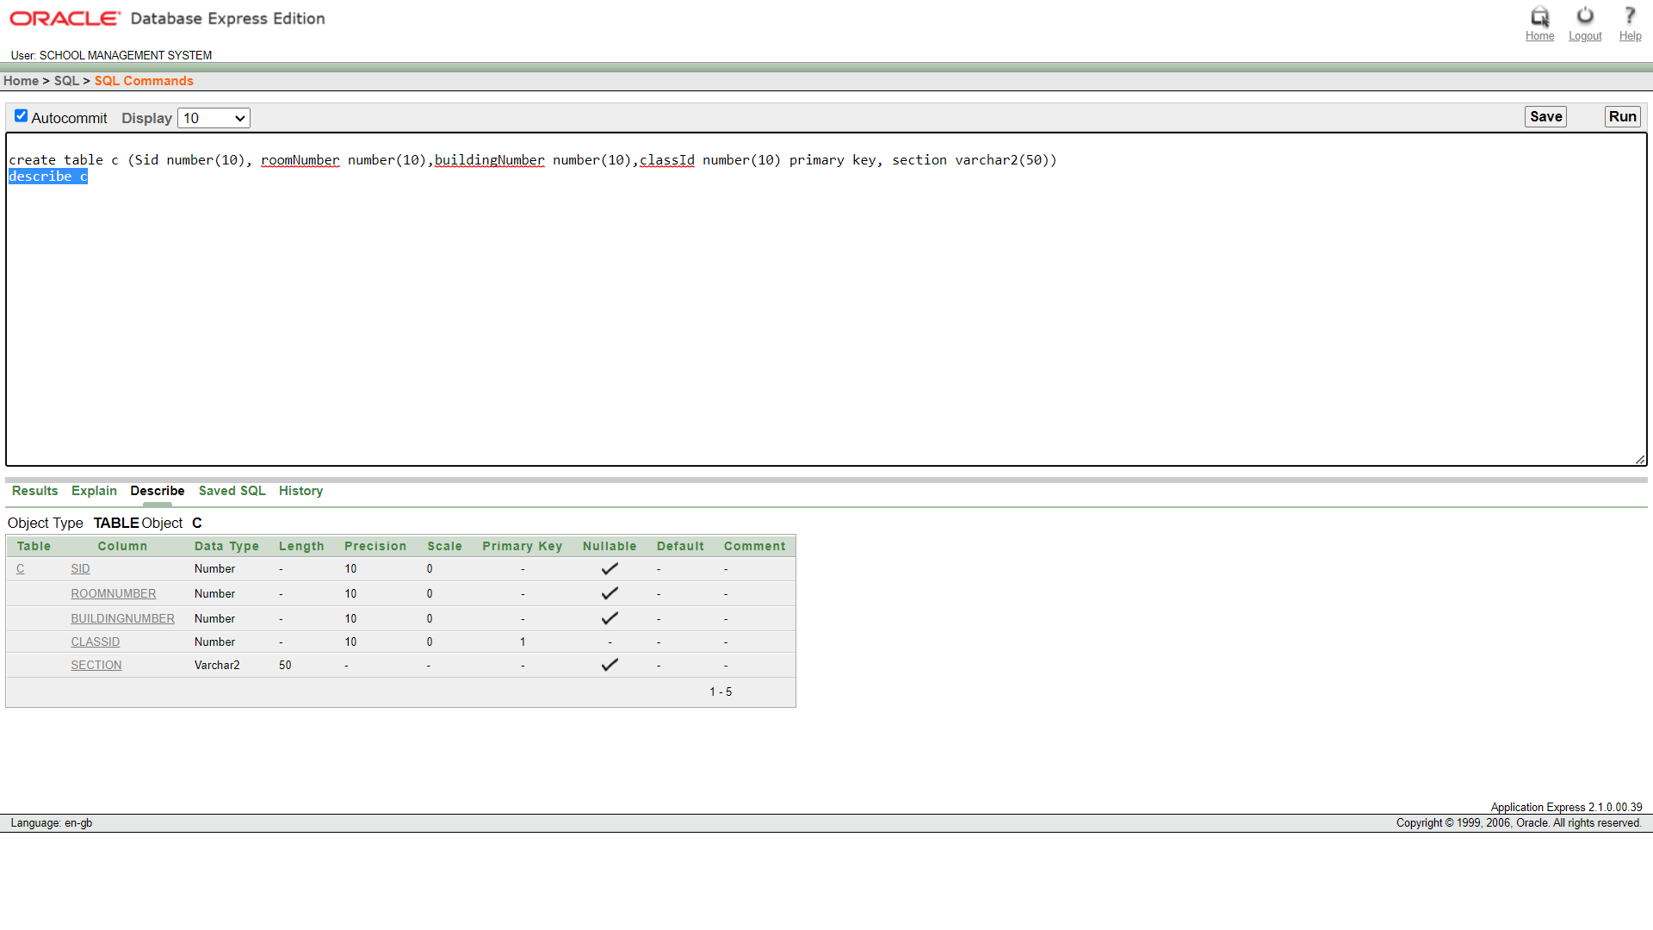

BOOK1 TABLE

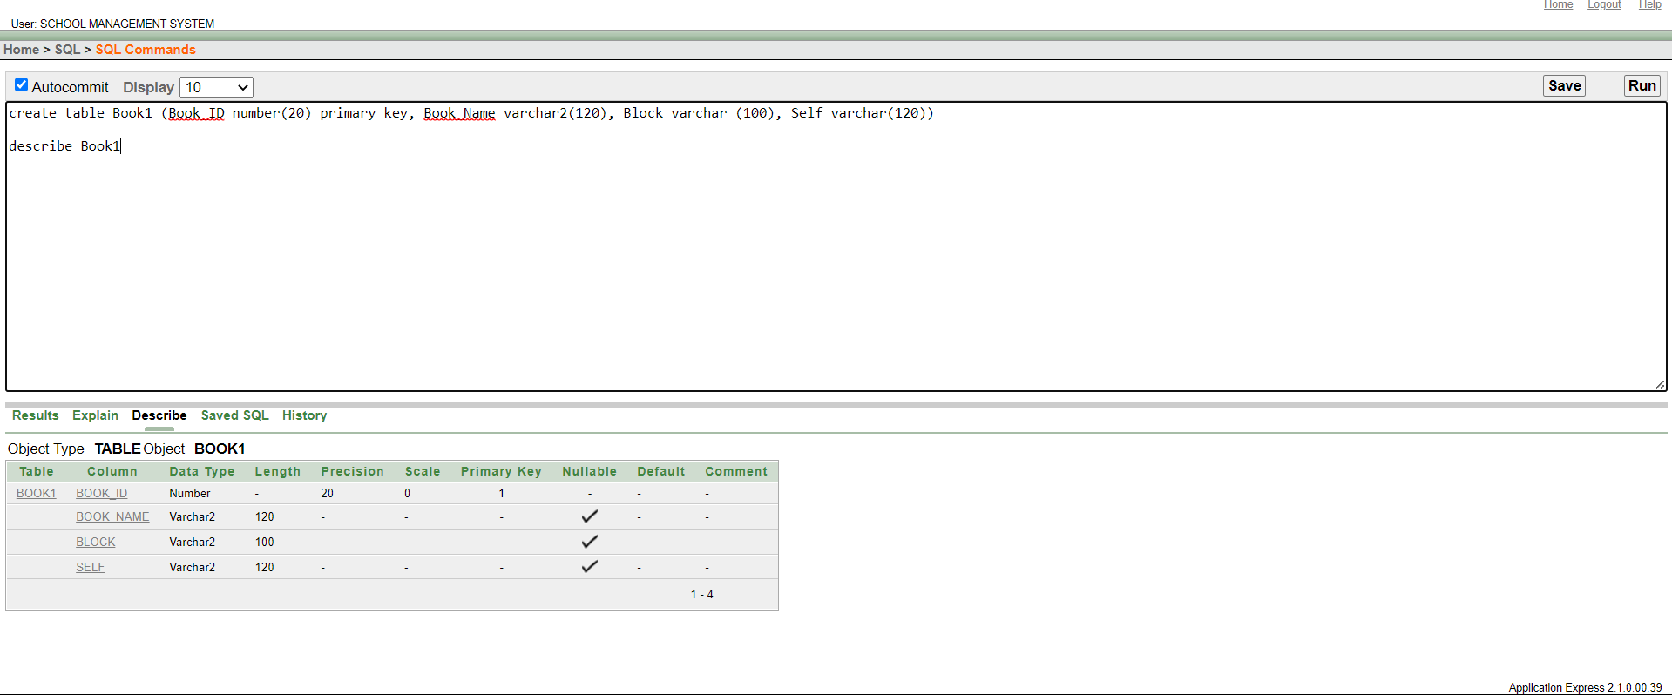

B TABLE

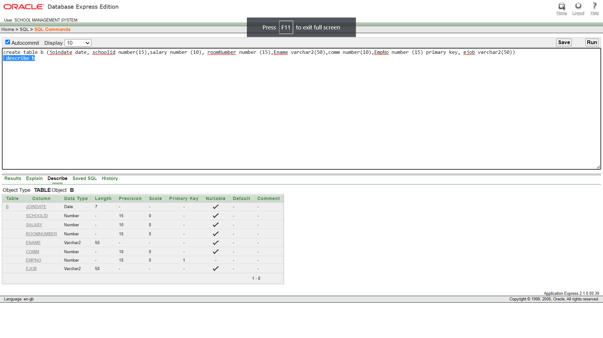

AB TABLE

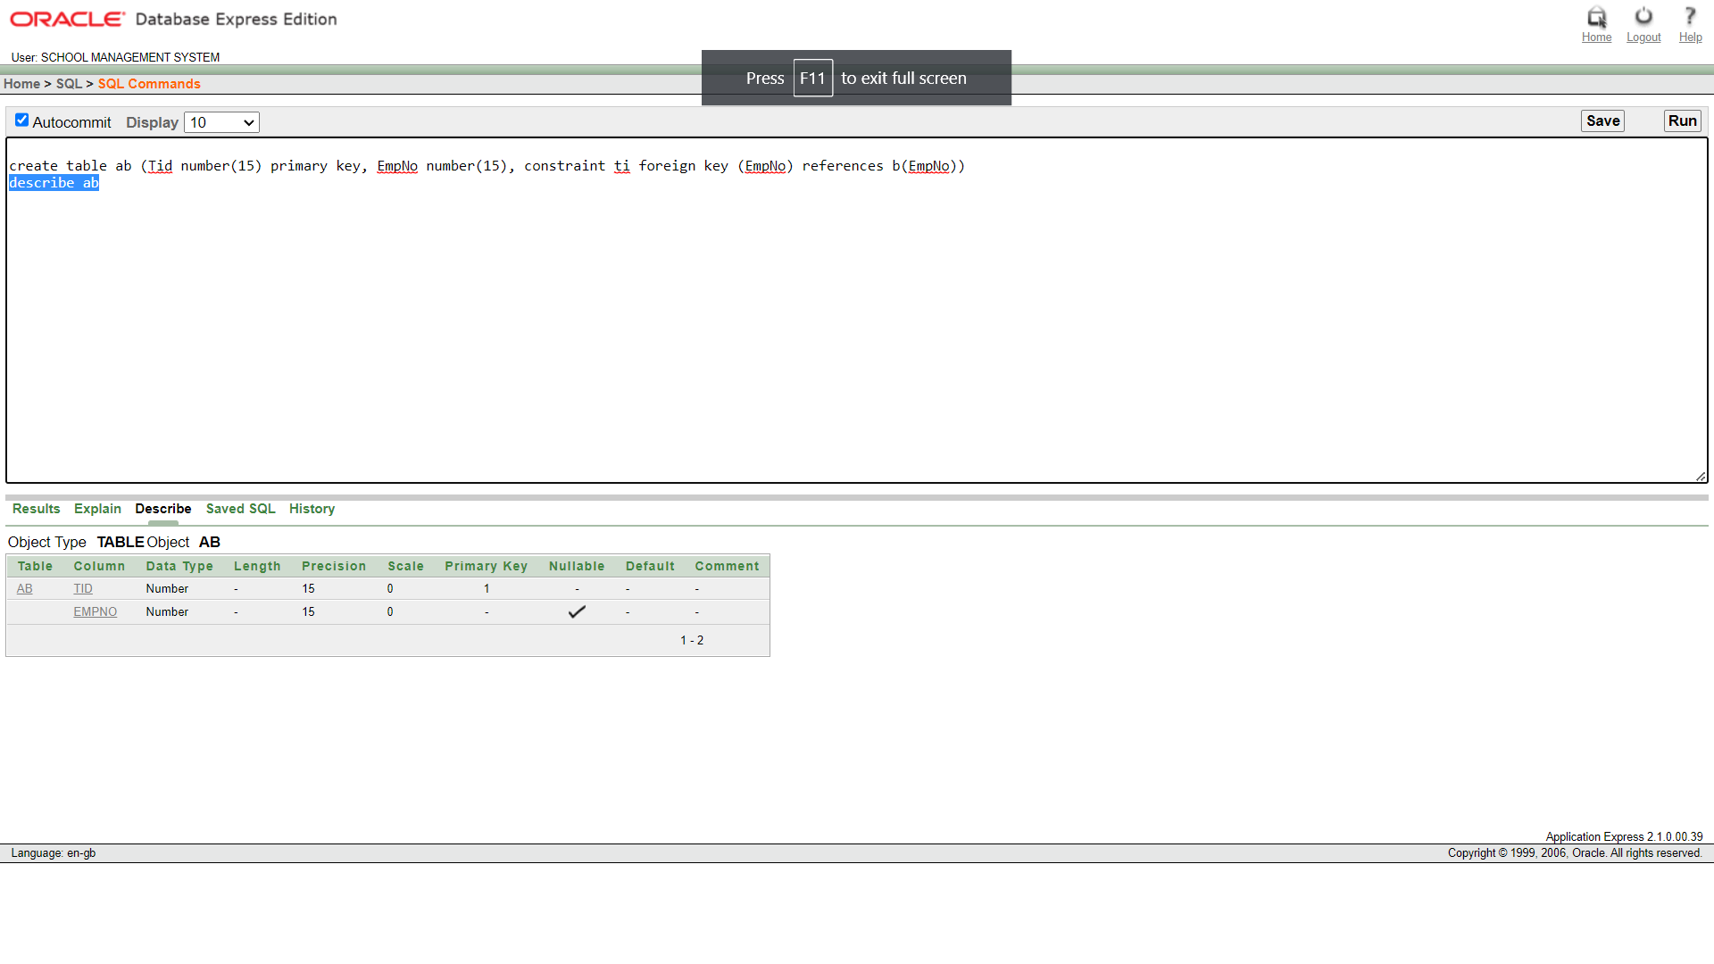

A TABLE

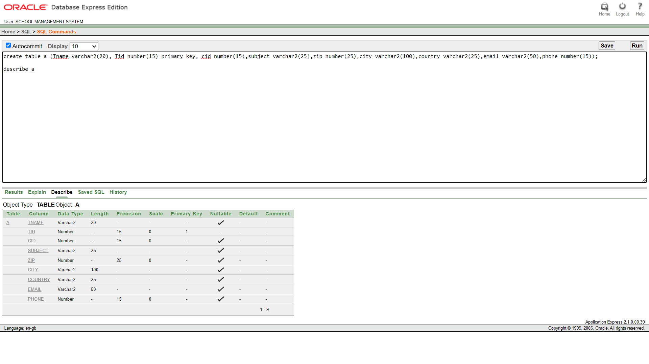

MM VALUE INSERT

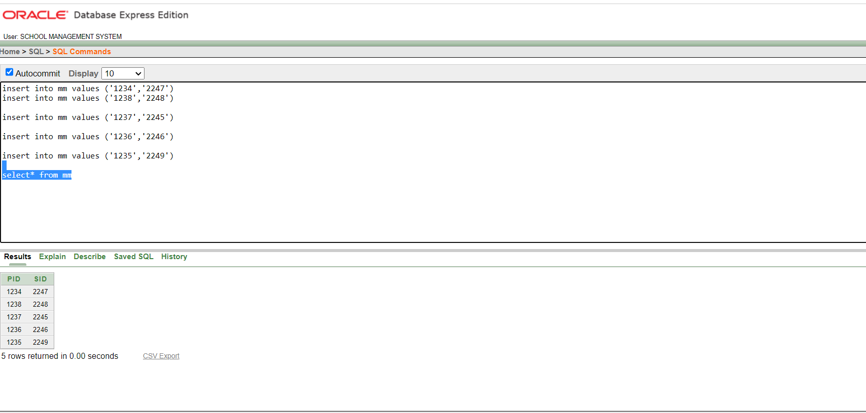

MEMBER1 VALUE INSERT

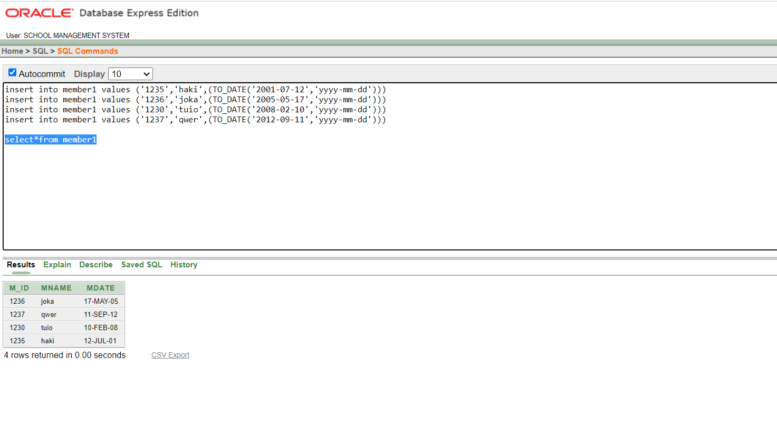

LIBRARY1 VALUE INSERT

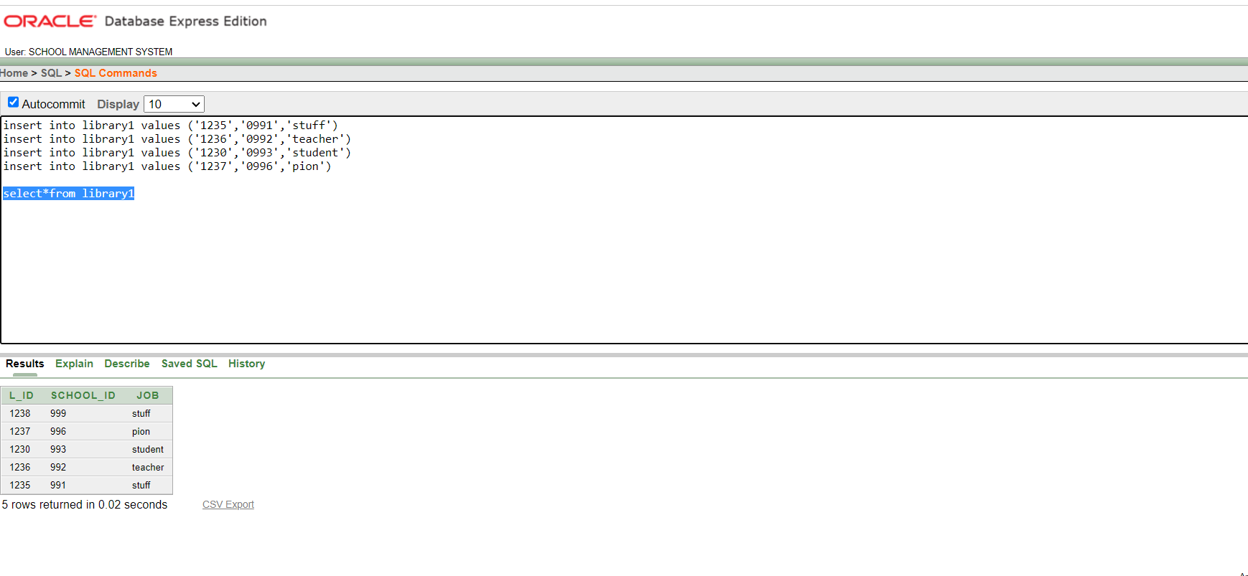

HAS2 VALUE INSERT

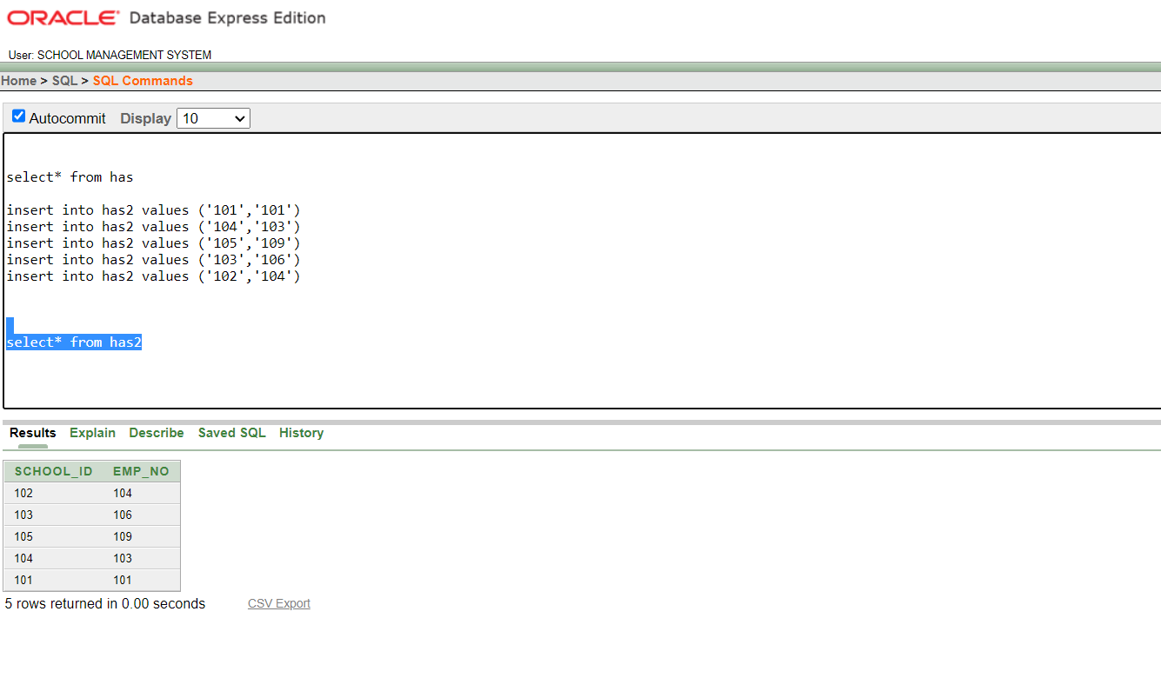

HAS1 VALUE INSERT

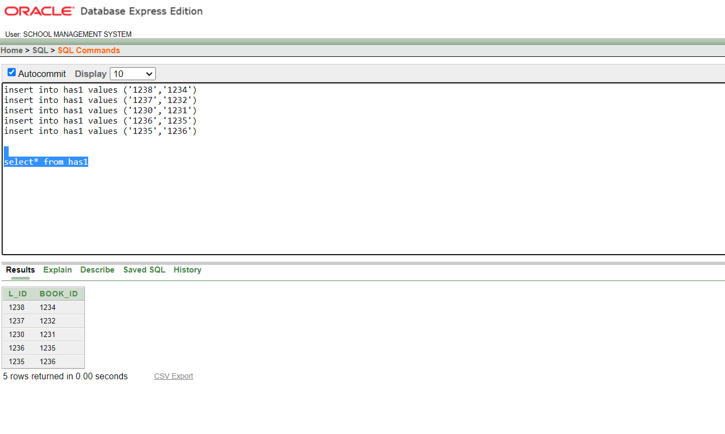

HAS VALUE INSERT

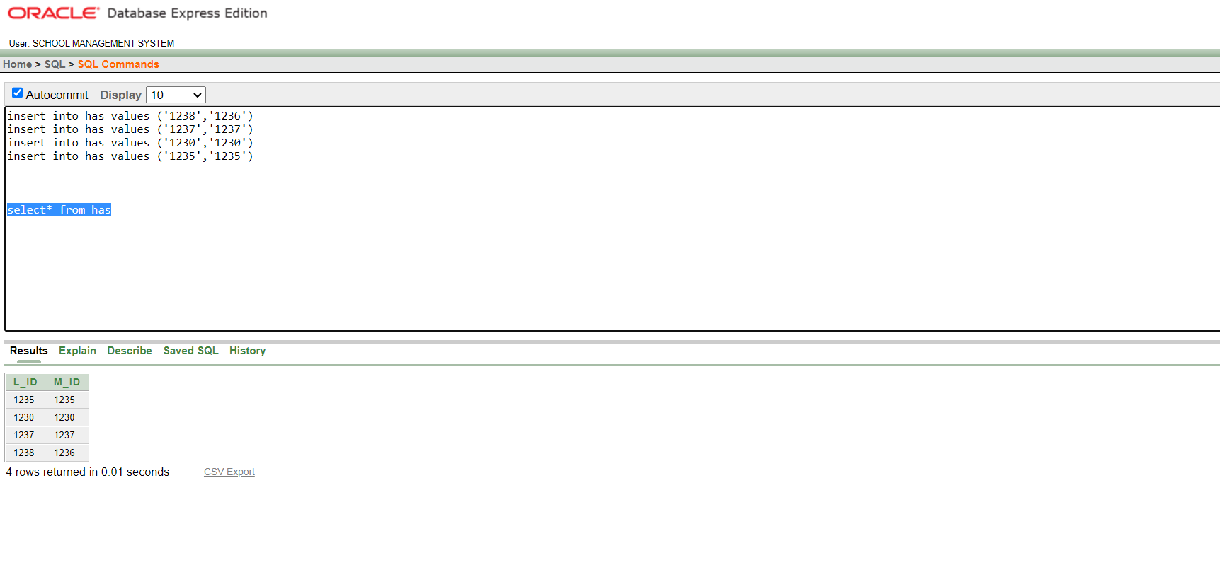

G VALUE INSERT

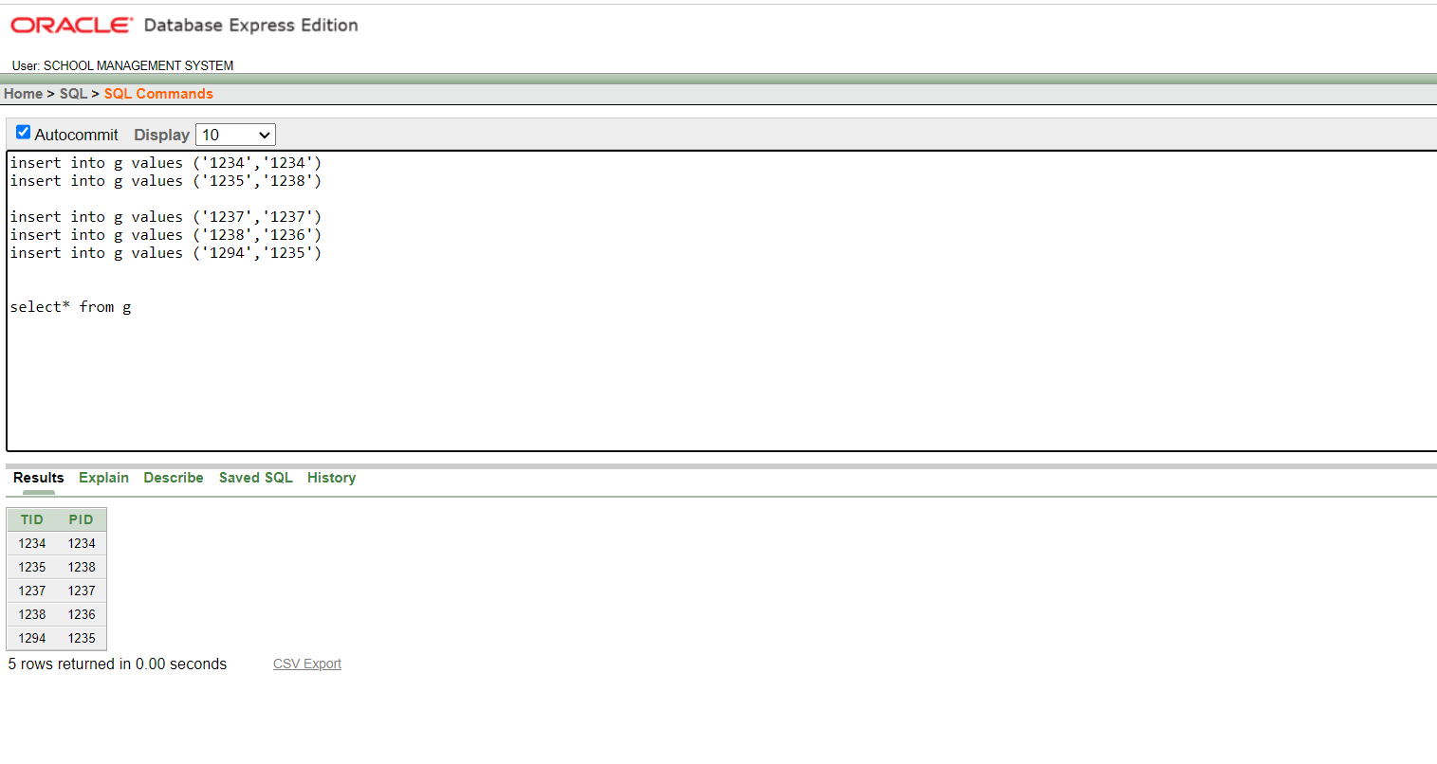

EMPLOYEE1 VALUE INSERT

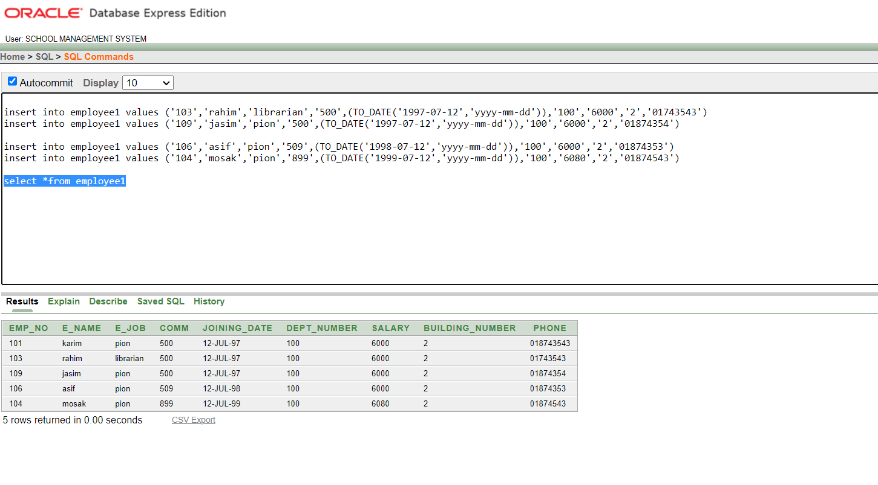

D VALUE INSERT

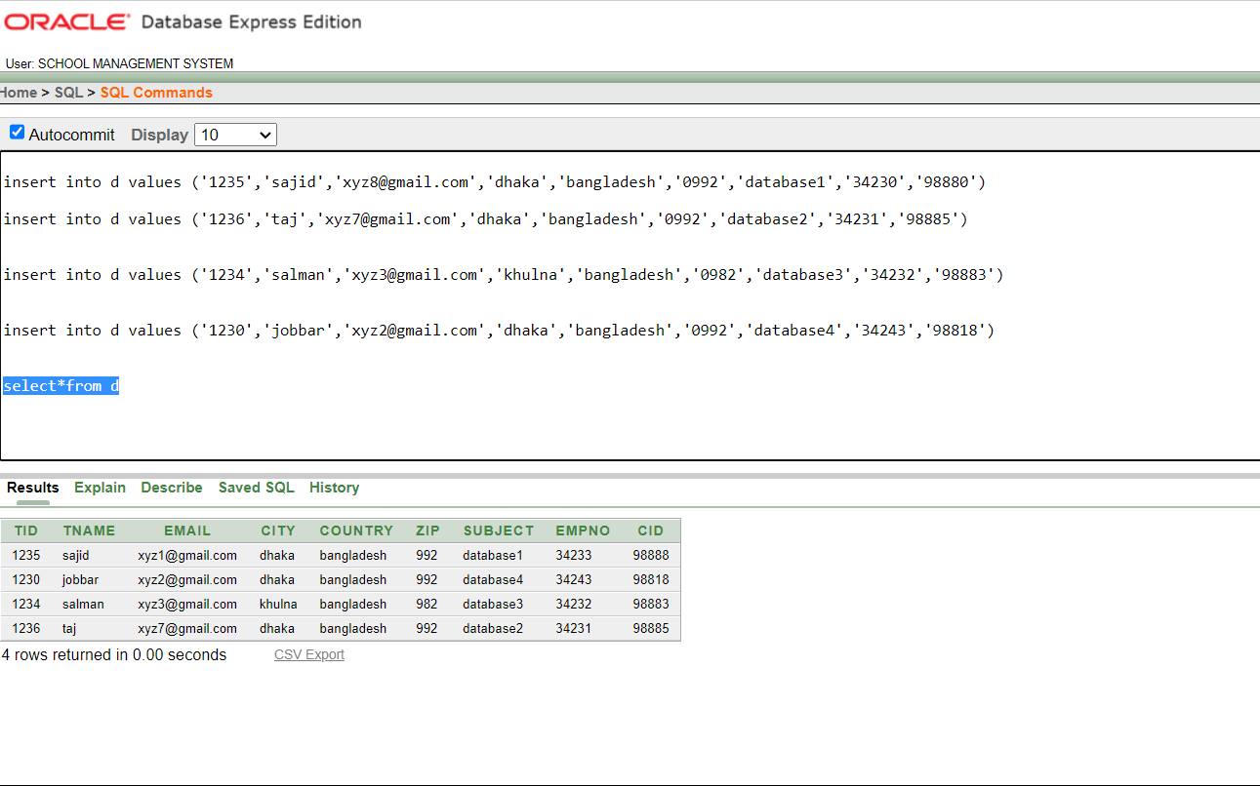

C VALUE INSERT

BOOK1 VALUE INSERT

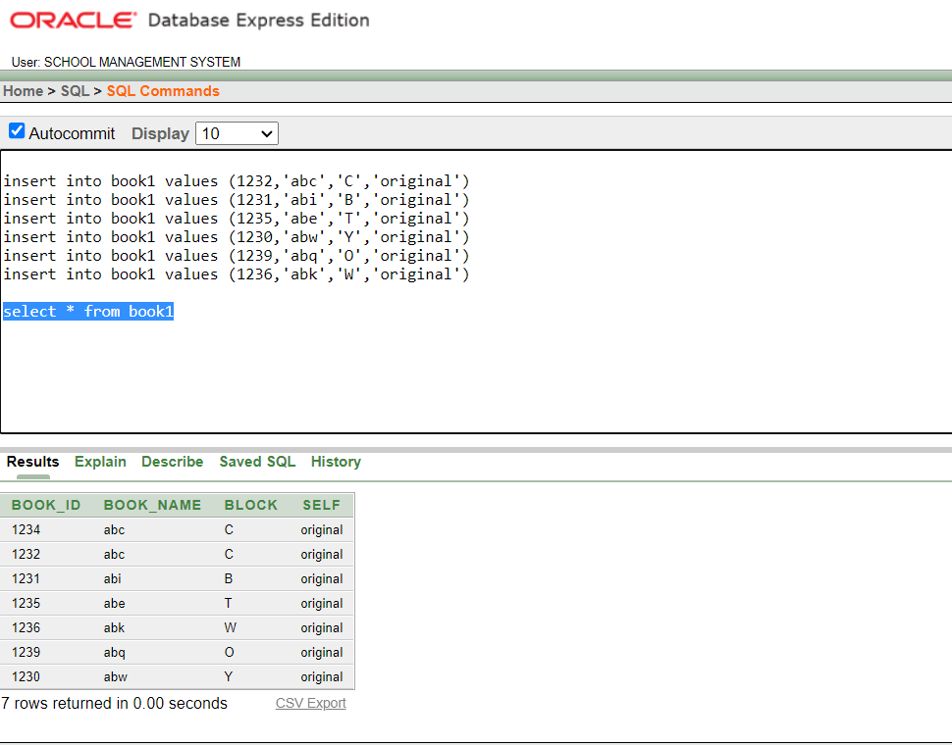

B VALUE INSERT

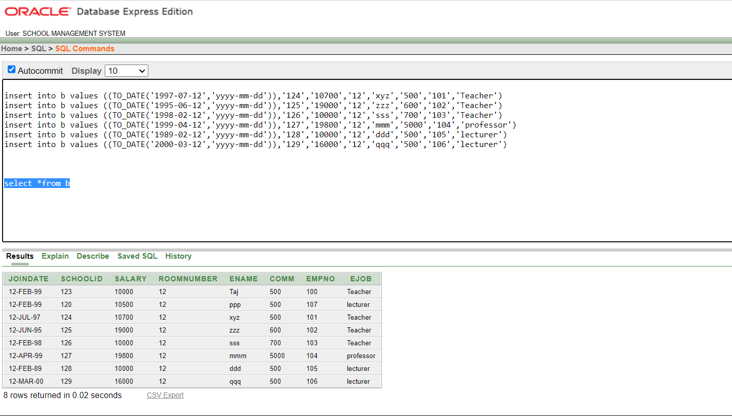

AB VALUE INSERT

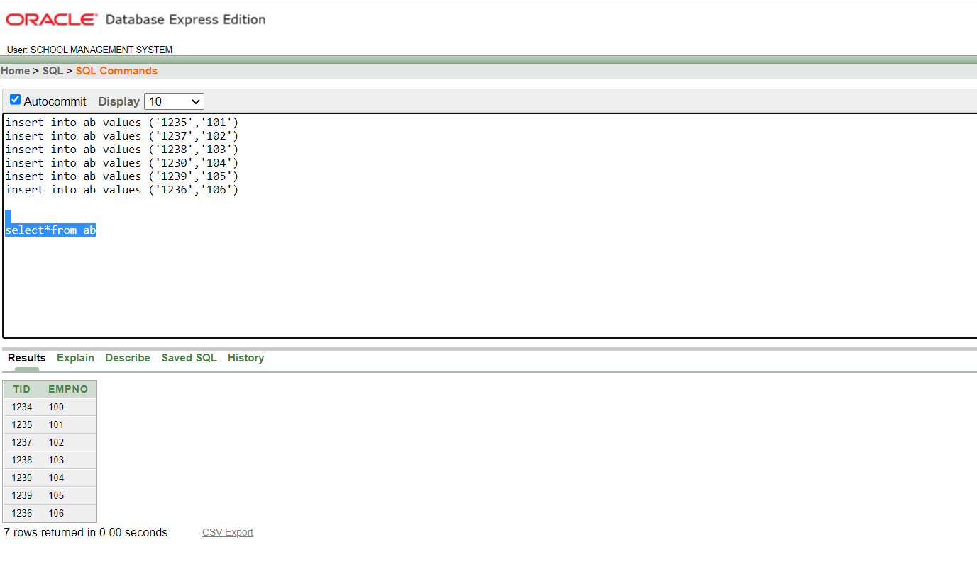

A VALUE INSERT

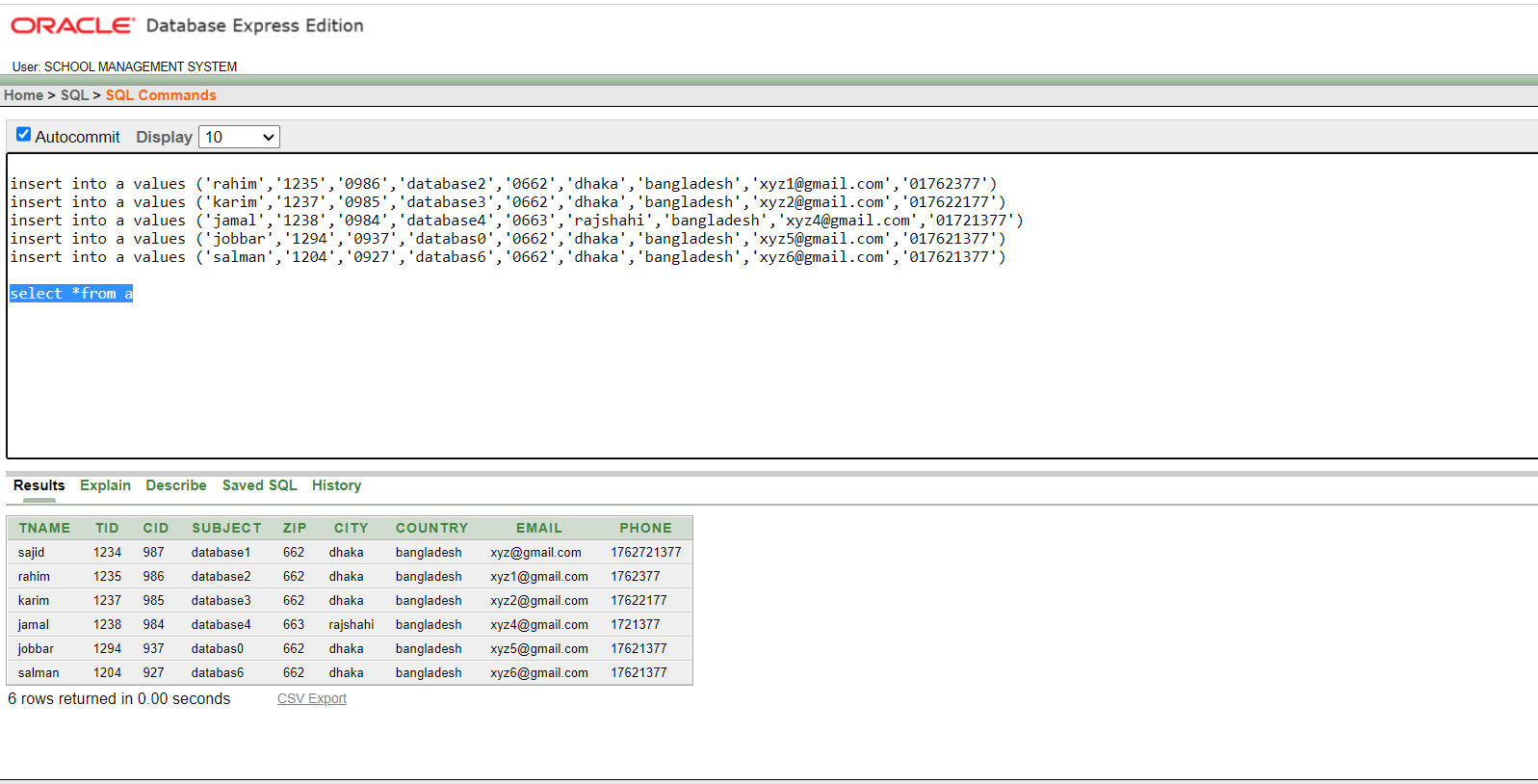

PM3 VALUE INSERT

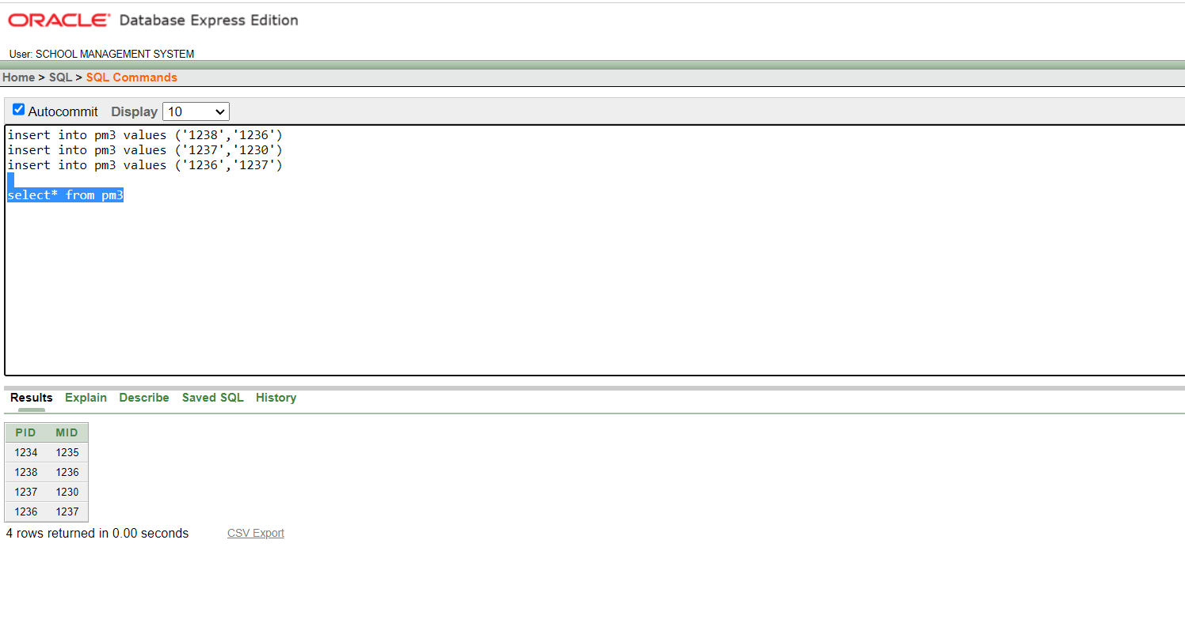

PM2 VALUE INSERT

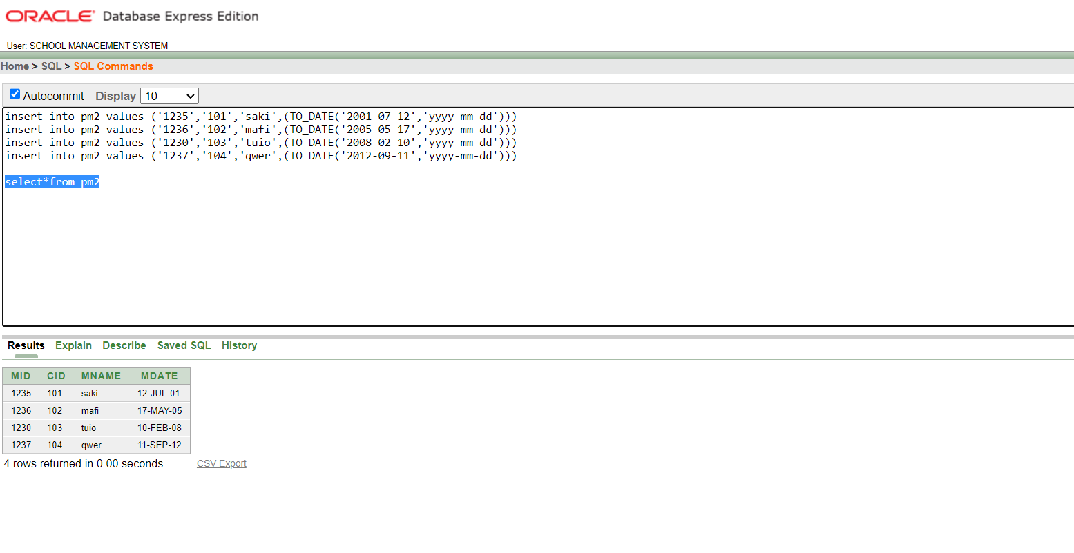

PM1 VALUE INSERT

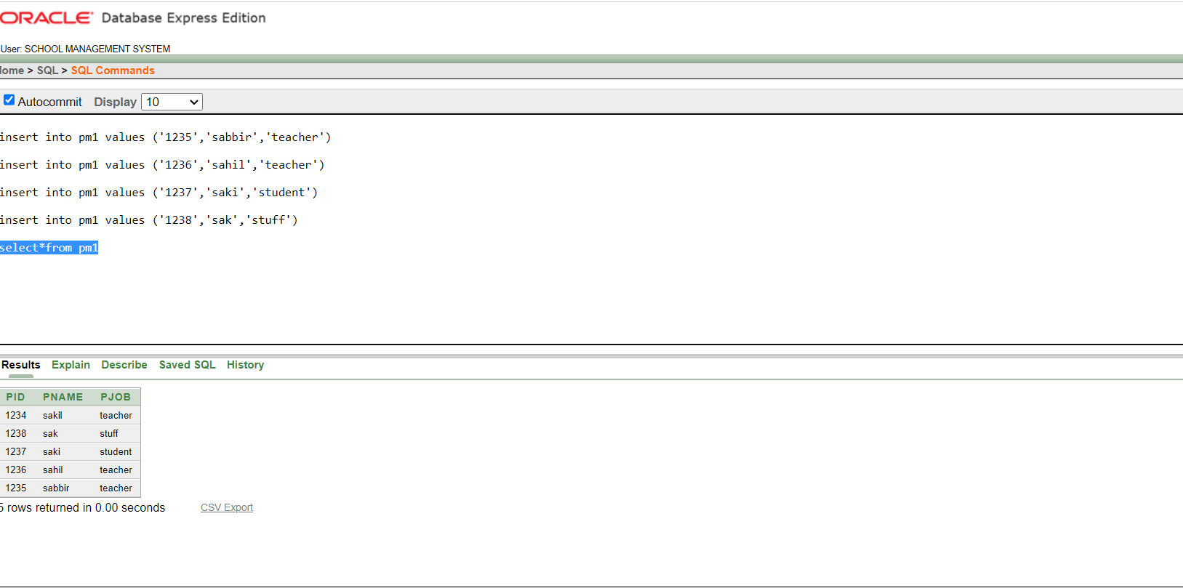

QUERY TEST

1. Write a query to list the name and salary of employees who earn more than $10700 and

are in school id 120 or 127. Label the columns name of employee Employees and salary as

Monthly Salary.

select ename, salary

from b

where schoolid = 120 or schoolid = 130

and salary>10700;

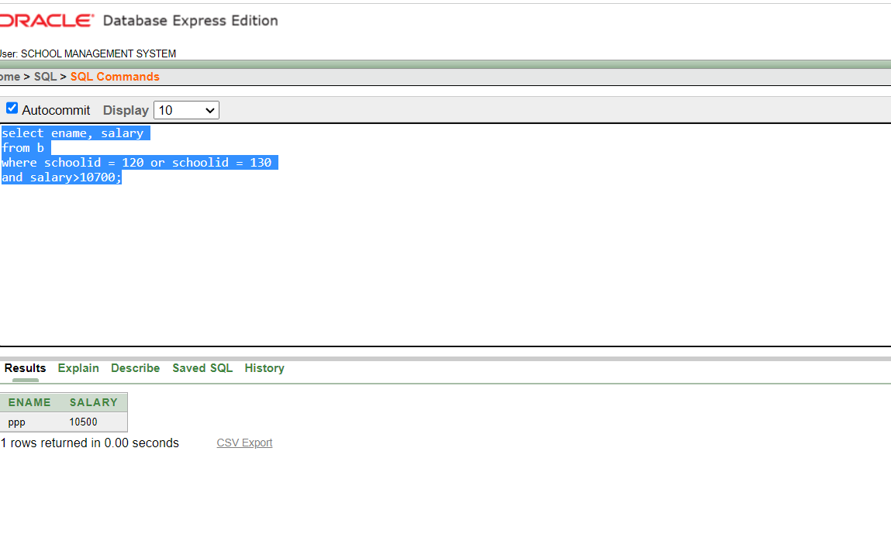

2. show the deptno,avg salary from employee1 group by dept no

select DEPT_NUMBER, AVG(SALARY)

from employee1

GROUP BY DEPT_NUMBER

3

show depno,max salary from employee1 group by deptno where max salary is greater than 6000

select DEPT_NUMBER, max(SALARY)

from employee1

GROUP BY DEPT_NUMBER

HAVING max(SALARY)>6000

4

Single Row Sub Query

show the ename , ejob,salary from table b where salary is maximum.

select ename, ejob, salary

from b

where salary = (select MAX(salary)

from b)

5

show schoolid,avarage salary from table b group by school id where avg salary is greater than the avg salary of emp 100

select schoolid, AVG(salary)

from b

GROUP BY schoolid

HAVING AVG(salary) > (select AVG(salary)

from b

where EMPNO = 100)

6

show ename,joindate, from table b where joindate is greater than ename ppp

select ename,joindate

from b

where joindate > (select joindate

from b

where ename = 'ppp')

7

show empno, ename,ejob from b where salary is greater than avg salary group by school id

select empno, ename, ejob

from b

where salary > ANY (select AVG(salary)

from b

Group By schoolid)

8

Equijoin

write a query that will join empno,ename,deptno from employee1 and zip,city from a table

select e.emp_no, e.e_name, e.dept_number, d.zip, d.city

from employee1 e, a d

where e.e_name = d.tname

VIEW

1. Create a view called EMP_VU based on the employee number, employee name, and

department number from the EMP table. Change the heading for the employee name to

EMPLOYEE.

CREATE VIEW EMP_VU

AS SELECT EMP_NO, E_NAME AS "EMPLOYEE", DEPT_NUMBER

FROM EMPLOYEE1;

select *from emp_vu

CONCLUSION

This is our SCHOOL MANAGEMENT SYSTEM database project. Through this project ,In future we can manage school’s data with good management .If we need any kind of information we can use this project to find out that data easily.